Spine Road Update – 06.07.2021
As you see here, two members of Weldon Parish Council again in talks with Persimmon, NNC and Tom Pursglove on behalf of the parishioners to find out the issues delaying the opening of the Spine Road. As soon as they have more information it will be posted on the website.
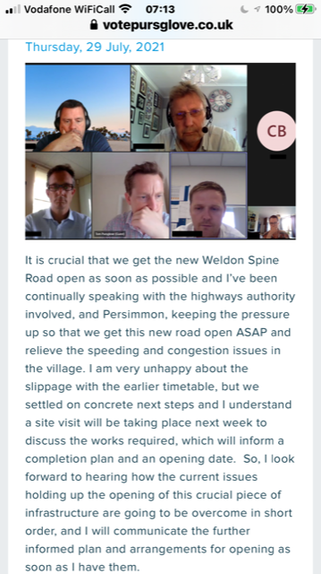
We appreciate their time as it’s been a long process. Keep up the good work.

