Traffic Working Group
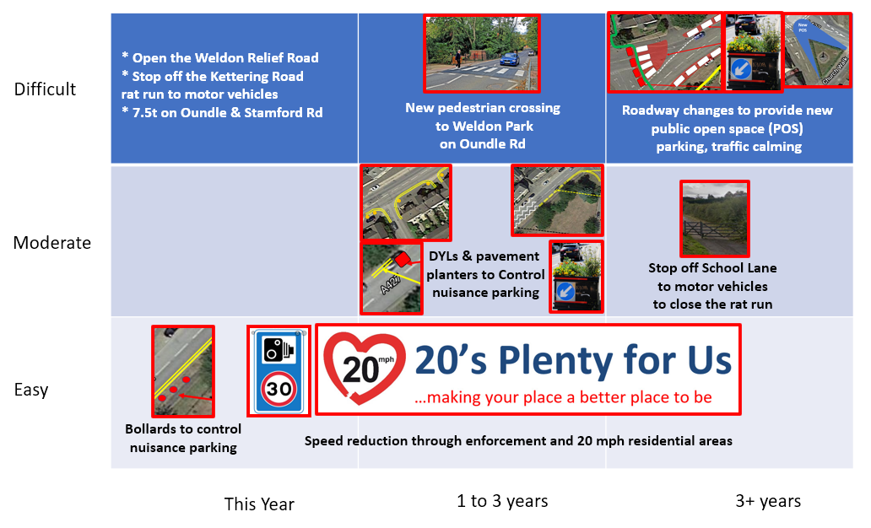
Weldon Parish Council set up the Traffic Working Group after residents contacted us in summer 2020. The group consists of Parish Councillors and Residents, the Ward Councillors for NNC are also invited to attend. The group has met monthly (with a summer break in August) and liaises with NNC Highways Authority and Developers, both current and furure, to make our parish a safer, cleaner and quieter environment.
The group has:
- delivered traffic calming on Stamrord Road
- worked with the Local Authorities to get a Pelican Crossing across the A43
- worked with our MP to get the Weldon Relief Road progressed
- applied for 20mph zones (rejected by NNC Highways Authority)
- placed 30mph advisory signs in the village where the speed issues are greatest
- Run 3,600 leaflet survey to collect residents requirements
- created a vision document and discussed our requiremnents with NNC Highways
- worked with NNC Highways Authority to run an advisory 20 signed scheme
- initiated a 20’s plenty campaign and worked with the schools to encourage theirs
- worked with the Highways Authority to review double yellow lines
- engagued with the Police Safer Roads Teams to get speed enforcement action
- installed bollards and planters to reduce nuisance on pavement parking
- contacted numerous companies where their HGV drivers had violated 7.5t limits
- got NNC to agree to refurbish the bus shelters on High Street
- supported Persimmons offsite traffic calming measures

