Plastic Bottles and Painted Pebbles
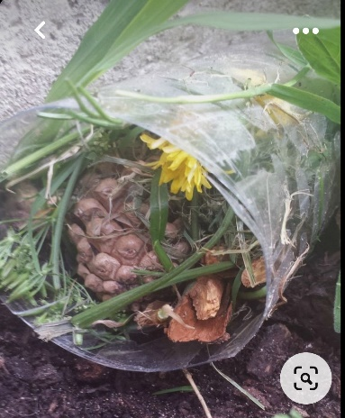
Plastic Bottles can be very useful to make bug hotels, poppies, and bottle top flowers.
Cut off the bottom and the top, giving you a cylindrical plastic middle section. If you want, make two holes for a piece of string to go through. Knot the string together so it can be hung up. Or it can be placed on the ground. Fill the cylinder with twigs, moss, grass, pinecones, all various garden matter for the bugs to hide in their comfy hotel.
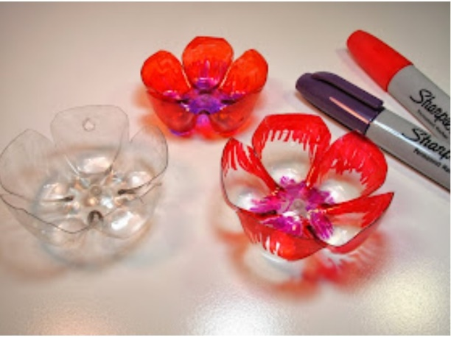
The bottom part can be left as it is and painted or use sharpies to colour and make a flower.
You can cut the edges to form petals, as shown here.

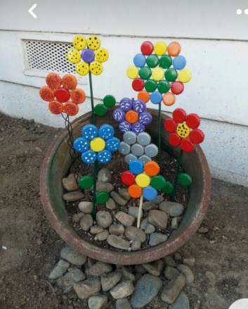
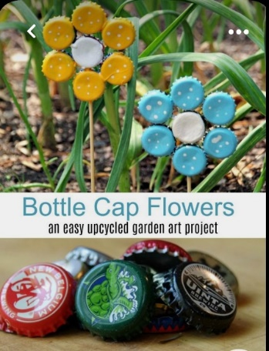
The tops, once washed, can be painted, and glued together to form a flower.

Painted pebbles can be a good way to brighten up the flower borders. Certainly, provide more interest in our Weldon sensory garden.
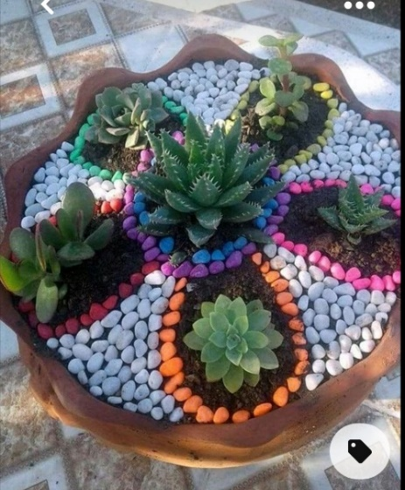
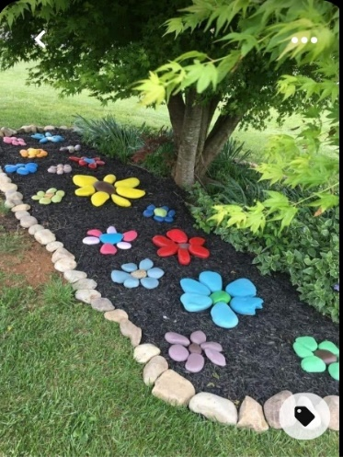

So, start collecting and remember to wash the pebbles and bottles first before creating.
From the ideas shown even a simply coloured pebble and top can be very effective. Here are some more ideas!

