Sowing seeds –
Toilet Rolls are biodegradable because they are made of the same natural material as paper-like wood pulp. So, they are ideal to use as plant pots to grow seeds and then place straight in the garden once the seeds have grown ready for planting out.
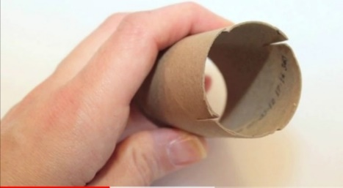
- Cut the toilet roll in half. At one end cut 1 inch slits x 4.

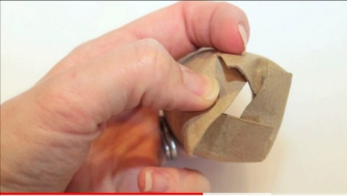
- Fold the cut sections in towards the centre of the roll.
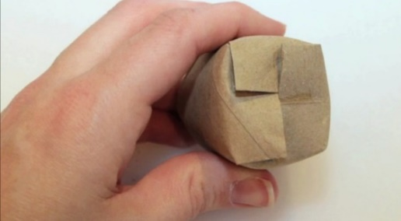

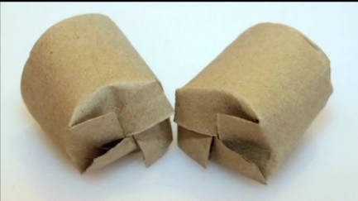

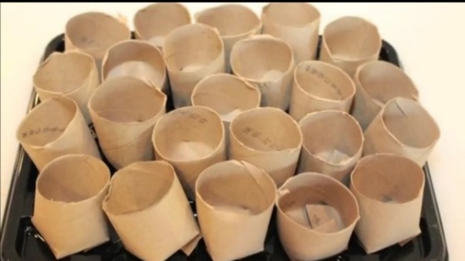
- Place the seed pots on a tray, or bowl and fill with soil. Moisten the soil and pot. Plant your seeds and watch the wonder start.

When the seeds have grown and are ready to plant out, the whole pot can be planted in the ground. No need to disturb the seedling by getting it out of the pot.
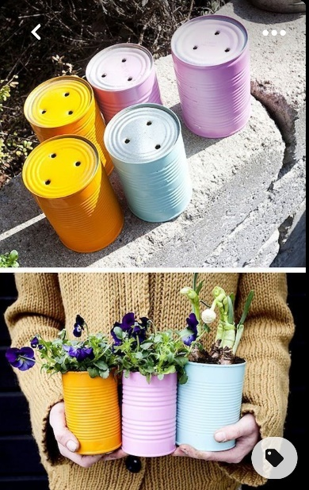

Food Cans are good to upcycle into planters as they have a coating inside to stop them rusting. However if not then paint or varnish on the inside and outside to make a lovely display.
- Clean the can
- Make a hole in the botttom ( adults help)
- Be creative and paint your can.
- Fill with soil and plat your seeds/flower.
Brings colour and joy for you and the bees and butterflies.

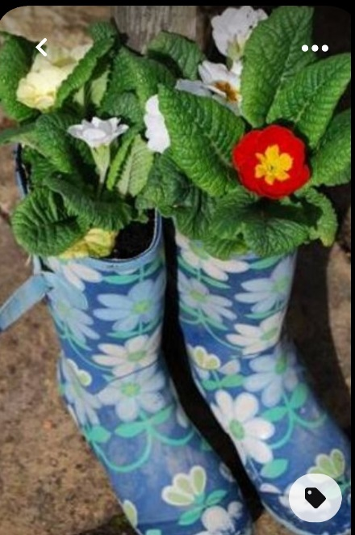
Few more ideas –
