Please keep your dogs on a lead or under close control
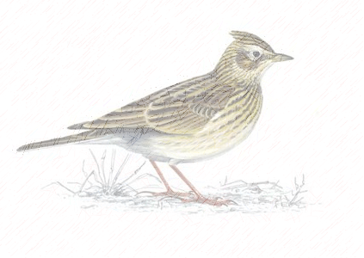
Skylarks will soon nest on this grassland patch!
Skylarks are ground nesting birds and they are known to love Weldon Woodland Park!
However, nesting on the ground makes them particularly susceptible to disturbance and to high death rates.
Please help us help them simply by using the paths provided between March and August!
Skylarks have been put on the UK Birds of Conservation Concern Red List because they are in critical decline.
Source: RSPB

