

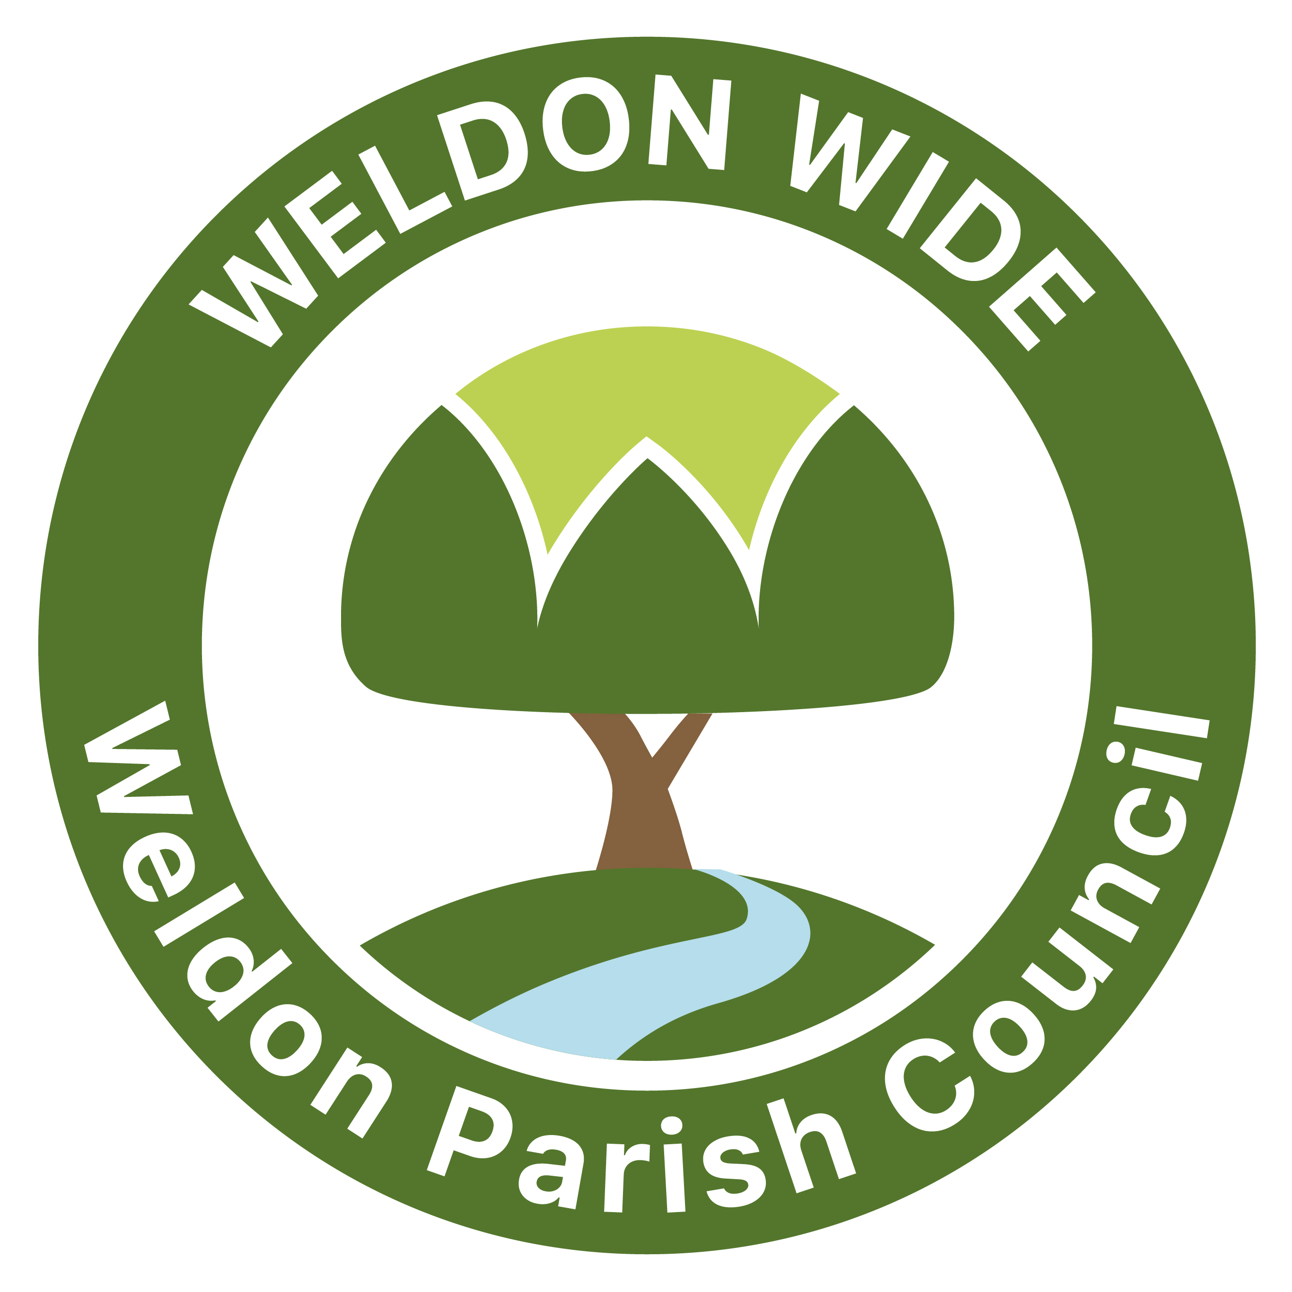
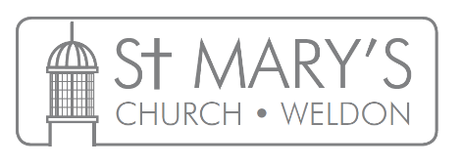
Youth Work for the Weldon Community

Proud Winners of the NAYC President’s Cup 2022!!!

Weldon Parish Youth Work update
Reporting to Weldon Parish Council and PCC May 2023

May has been a short month with only 2 youth club sessions due to 3 bank holiday Mondays so a little less to report than usual. We have a consistently high number of young people coming to youth club with new enquiries each week. This month we were gifted a pool table from a member of the community choir. This was an amazing donation which we are already getting good use from. We share the building with the choir on a Monday evening and members are always interested in what we are doing each week. We are also very grateful to the Community Centre for allowing us to store it along with all our other equipment.
May activities have included balloon modelling, a chocolate fountain, loom bands and preparing a football team for a 5-a-side tournament next month.
Some of our young leaders ran a Book Sale as part of the Kings Coronation Big Lunch celebrations at the village hall. The group were very well received and raised £135. We have decided as a group to top this up from tuck shop sales and are donating £295 to Save The Children. In our last youth club session all our young people worked together in groups to decide what 'virtual gifts' to buy and agreed on A Place In School For A Child, Water Filter, 2 Goats and 5 Mosquito Nets.
We were approached at the Big Lunch by a prospective volunteer interested in becoming involved in our work. She has since submitted her application and shadowed us at a recent youth club evening. Her DBS application is in progress and we hope to have her volunteering with us from next month.
The Handling Anger in the Family Parenting course run by myself and Emma Kirby (St Mary's Family worker) has now finished, with 9 parents completing our 4 evening sessions. Several parents were keen to go on further courses if provided, in particular the Additional Needs course. Feedback was extremely positive and a real life line for some attendees for whom support from other parents and additional 'parenting tools' have proved to be invaluable. These Care For the Family courses are such a great resource and I have been fortunate to be able to work in partnership with the local Hope for Families charity to deliver them. As most courses over recent years have been online it was really important to be able to offer an in-person course and the Congregational Church Hall proved to be the perfect venue.
In my ‘church hours’ I have delivered a youth church 'home group' evening and will be running a further inter-generational youth church session at the end of this month with food, games and worship.

Kirstie Lloyd-Uzoegbu
Weldon Parish Youth Worker

